**EXPERIMENT 8:**

Create a simple cloud web application for student counselling system using any Cloud Service Provider to demonstrate SaaS with the fields of student name, age, address, phone, subjects studied, Year of passing, percentage of marks, domain interest, etc.

**AIM:**

To Create a simple cloud software application for student couselling system using any Cloud Service Provider to demonstrate SaaS.

**PROCEDURE:**

**step1:** Go to zoho.com.

**step 2:** Log into the zoho.com.

**step 3:** Select one application step.

**step4:** Enter application name as student counselling system.

**step 5:** Created new application as student counselling system.

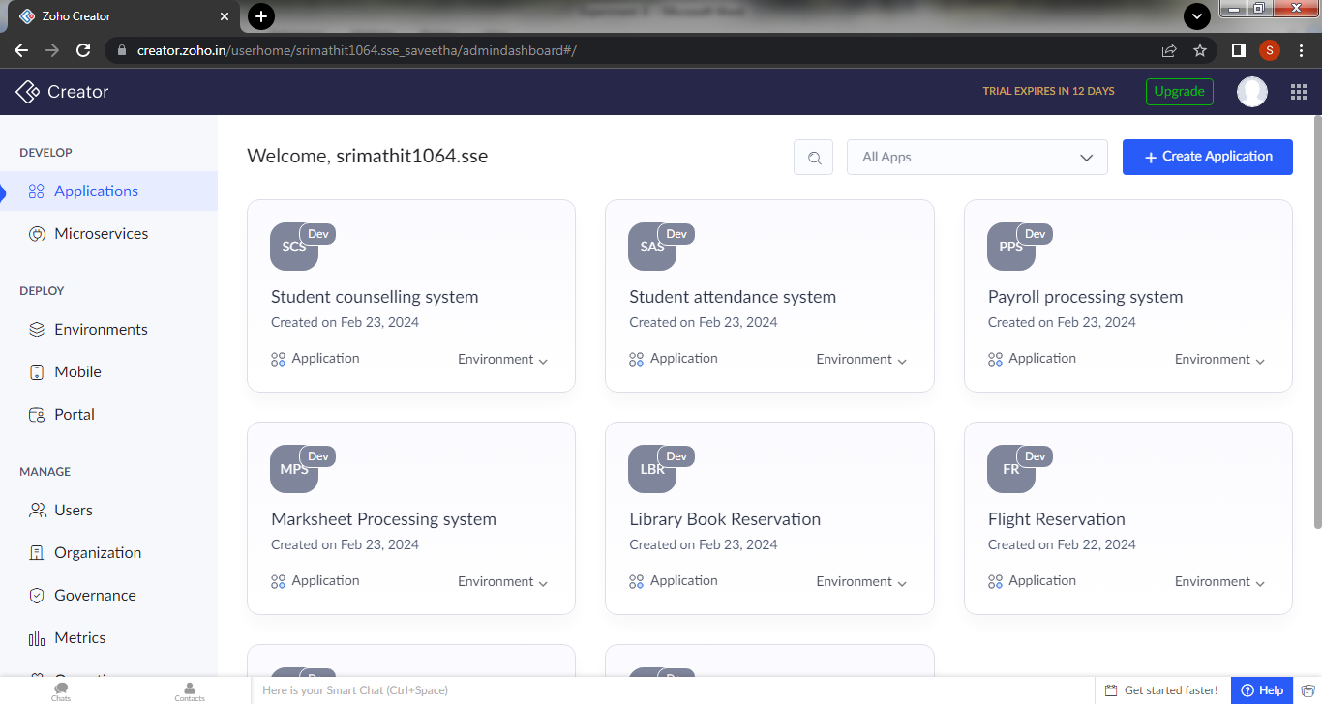

Step 6:create a new form for login page

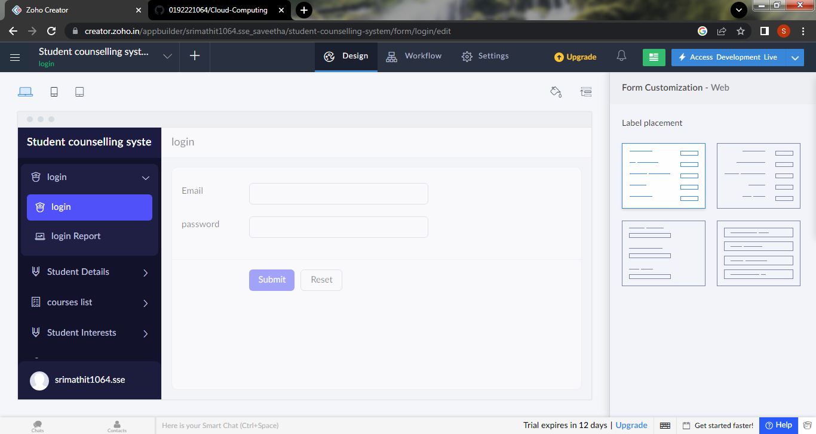

Step 7: create a second form for student details

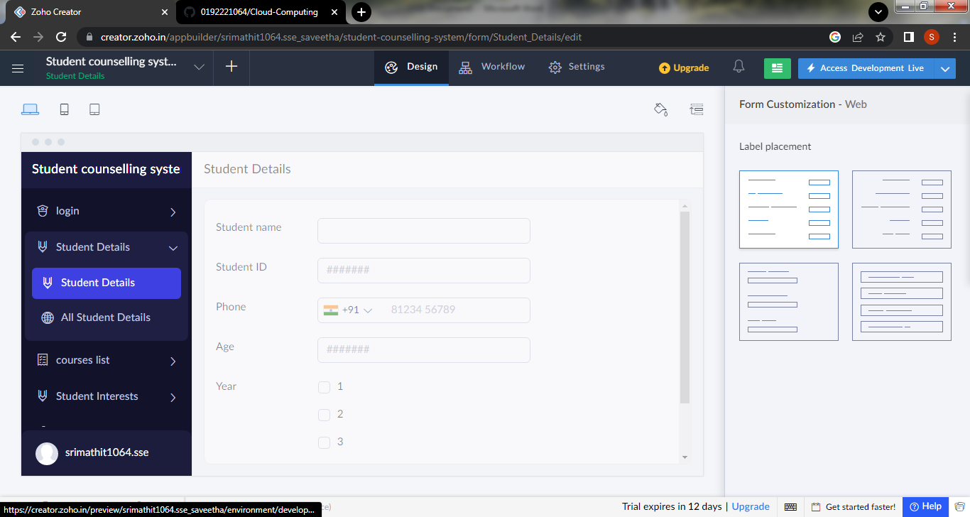

Step 8: Create a form for the courses list of the student

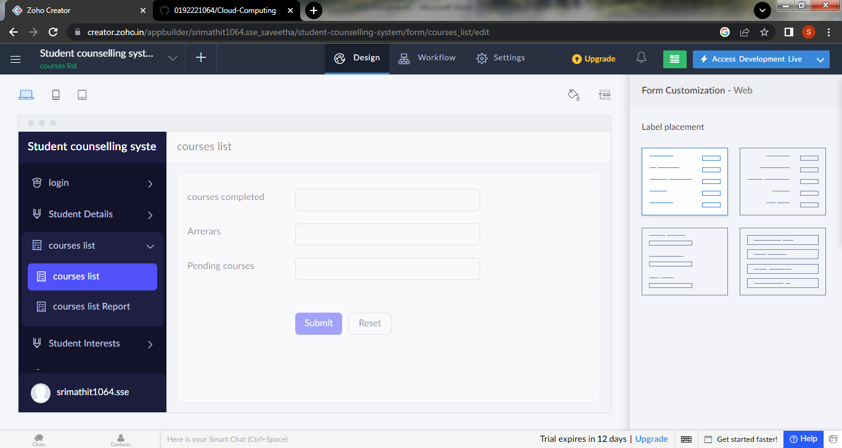

Step 9:create a next new form for to generate the mark details of the student

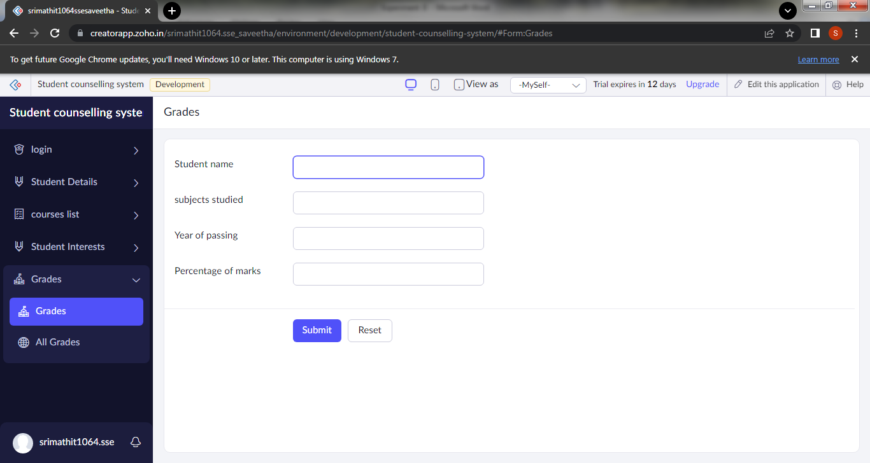

Step 10: click the access development to view the live output

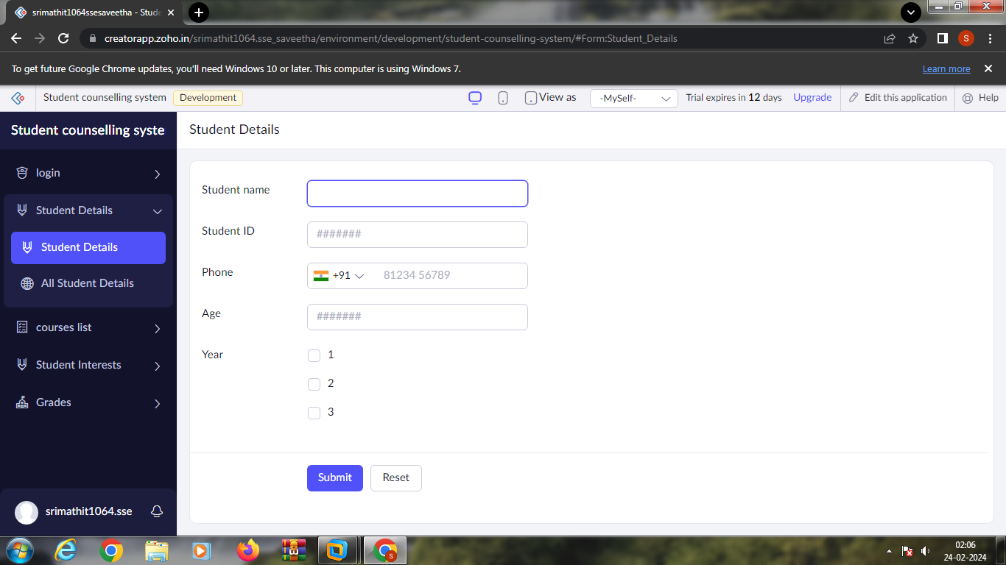

Step 11: click the report icon to view the data that are added

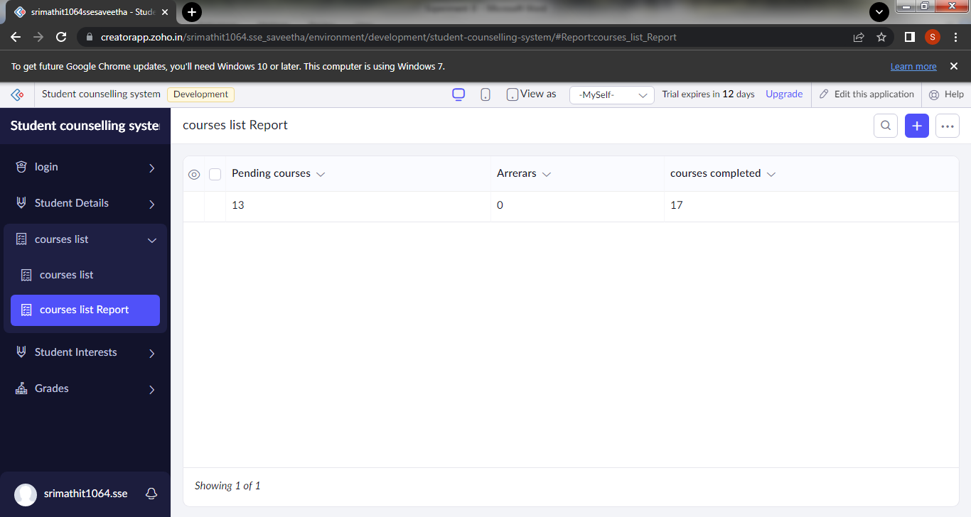

Step 12:click the mobile icon to view the output in mobile form

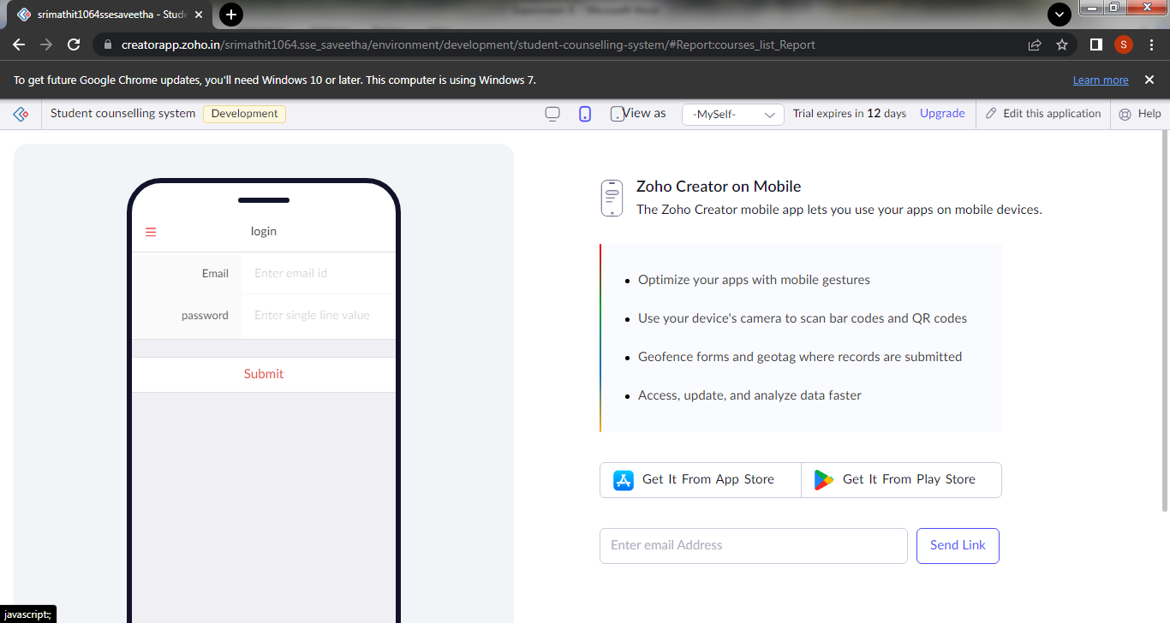

Step 13: click the tablet icon to view the output in tablet form

